EMERGENCY CONTACT SHEET
OUT-OF-COUNTRY LOCATION

Please carry this information with you at all times.

Emergencies

During your team’s travels, the Global Village program is available in the event of an emergency. You may distribute this information to your team members, but please be certain to use this only in the event of an emergency. Calls should be made in the order listed.

Team Leader | Name:  Mobile Phone:  E-mail:
Host Program | Name: host coordinators name  Office Phone:  Mobile Phone:  Email:
Travel Assistance Provider | Europ Assistance  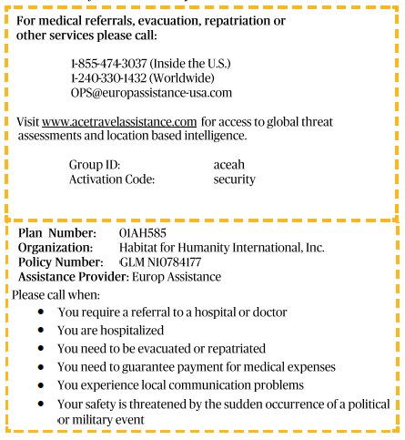
Habitat For Humanity Great Britain International Volunteering Programme | Global Village Department 24-Hour Access  Emergency Phone 1: (00 44) 79587 802 28  Emergency Phone 2: (00 44) 74877 682 29  E-mail: mcampbell@habitatforhumanity.org.uk
Habitat For Humanity International Global Village Program | Global Village Department (Monday-Friday 8am-5pm EST)  1-800-422-4828 ext. 7530  Emergency Hotline: 1-229-938-6999  E-mail: Volunteer911@habitat.org
Host Program National Director | National Director  Office Phone:  Mobile Phone:  Email:  Address:
Sending Country Embassy | Phone:  E-mail:  Address:  Web Address:

Updated 2018

